Baby Sign Languages By: Billy Truong
Sign: More Sign: Done Sign: Sleep Sign: Eat
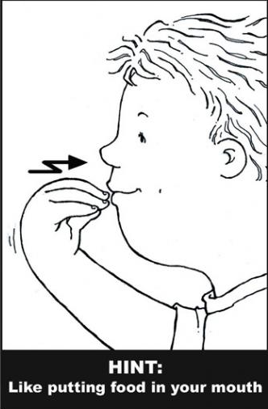
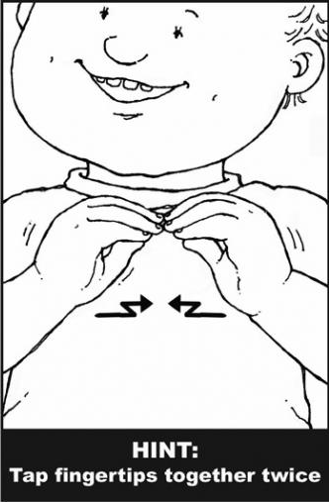
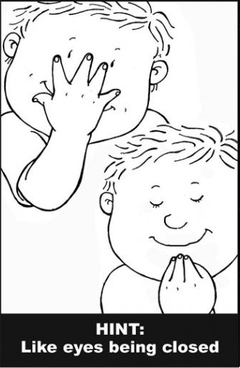
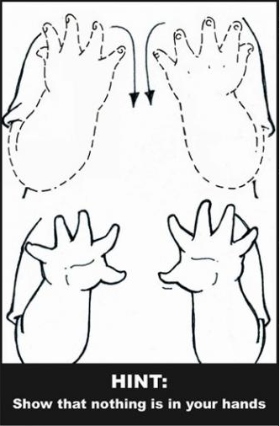

Sign: Milk Sign: Change Sign: Help Sign: Play
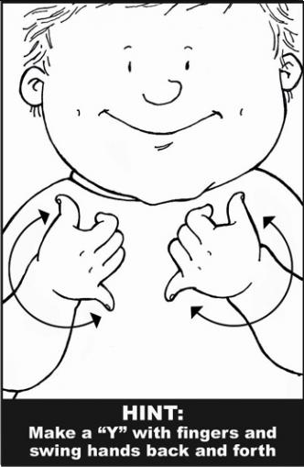
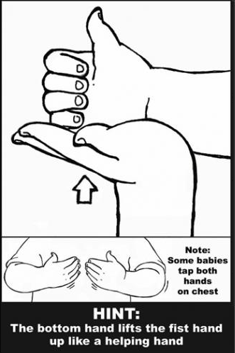
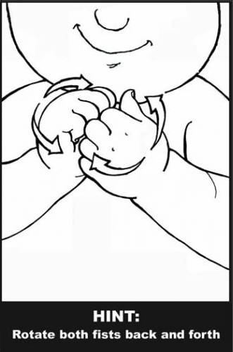
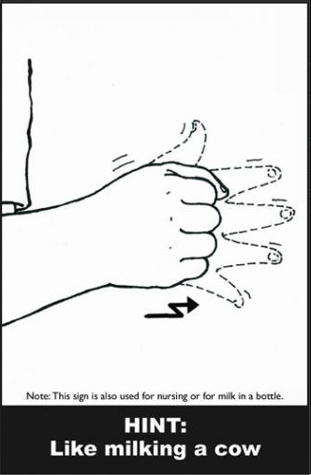

Sign: Yes Sign: No Sign: Water Sign: Book
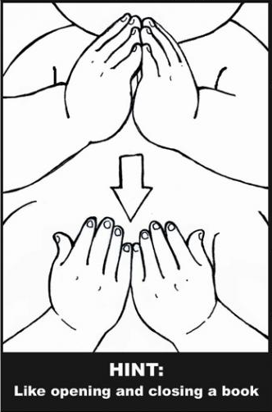
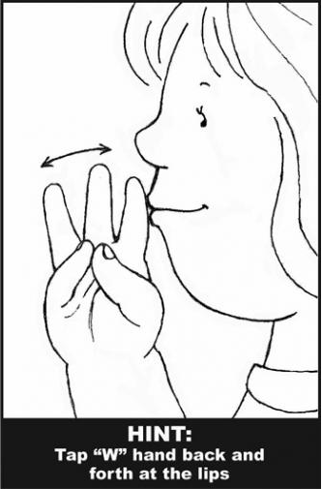
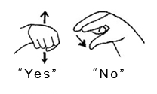

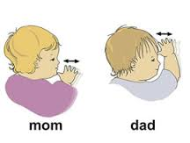
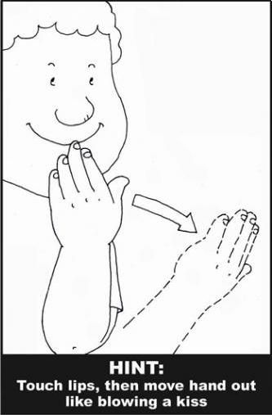
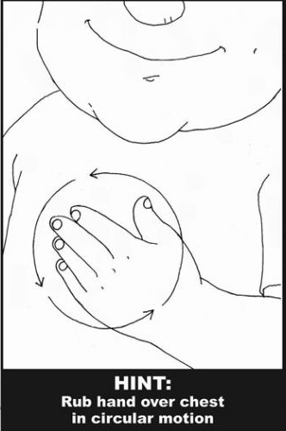
Sign: Please Sign: Thank You Sign: Mom Sign: Dad

Images and materials were gathered from the following websites:
http://drewsasl.weebly.com/ http://www.parenting.com/gallery/baby-sign-language-words-to-know https://en.wikipedia.org/wiki/Baby_sign_language

